# **World Happiness in 2024: How Social and Economic Factors Shape Well-being Globally**

# **Student Name:** Mohammad Aakash **Student ID:** 24079227

# **Introduction:** The World Happiness Report 2024 presents a comprehensive overview of global well-being, ranking countries based on self-reported life satisfaction and a range of social and economic factors. This report analyzes the 2024 dataset, focusing on the distribution and determinants of happiness across regions, the role of social support and freedom, and the characteristics of the happiest and unhappiest countries. By leveraging advanced data handling and visualization techniques, we aim to uncover patterns that inform both policymakers and the public. **Data Overview:** The dataset includes 137 countries, each with a "Ladder score" (happiness), regional grouping, and variables such as GDP per capita, social support, healthy life expectancy, freedom to make life choices, generosity, and perceptions of corruption. Data cleaning involved removing rows with missing values in key columns and ensuring consistent data types for analysis.

**Results & Discussion:**

**1. Ladder Score (Happiness) Distribution by Region**

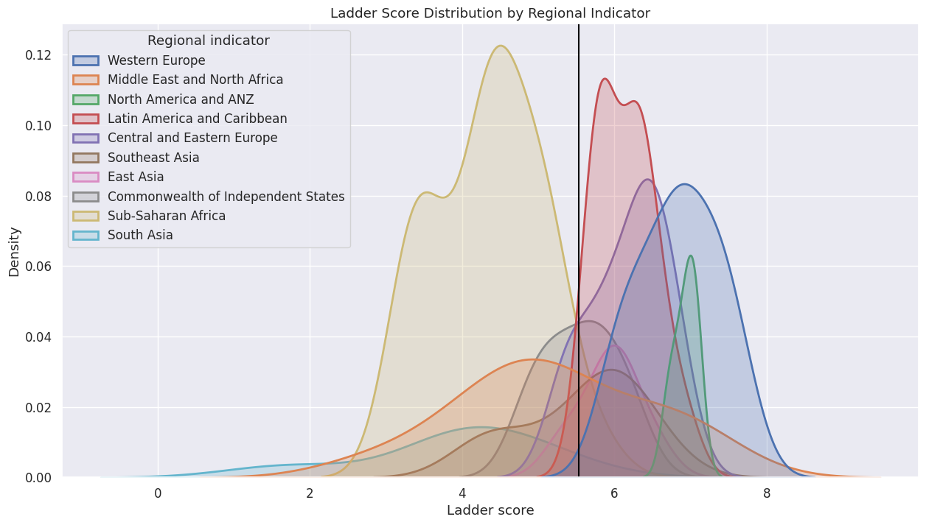

To begin our exploration of global well-being, **Figure 1** presents the distribution of ladder scores (a proxy for national happiness) across various world regions. The visualization clearly illustrates regional disparities in perceived happiness. Western Europe and North America & ANZ stand out with the highest concentrations of countries scoring above the global average, suggesting strong institutional and socio-economic support systems. In contrast, regions such as Sub-Saharan Africa and South Asia display broader, left-skewed distributions, reflecting lower average happiness and greater variability. This underscores the significant influence of regional development, cultural norms, and infrastructure on overall life satisfaction.

**3. Happiest and Unhappiest Countries**

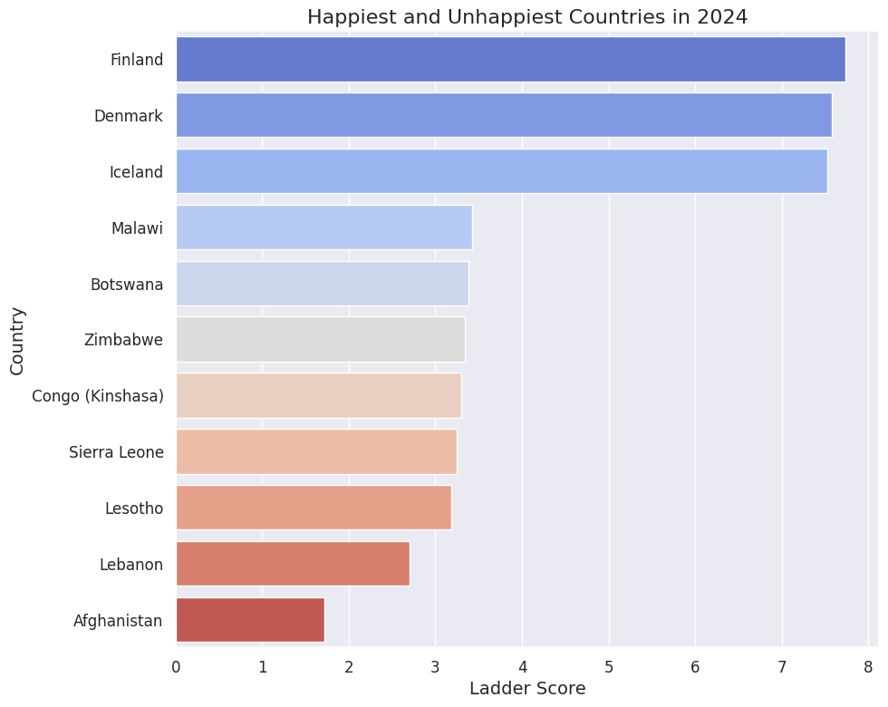

Building on the regional overview, **Figure 2** dives deeper by identifying the happiest and unhappiest countries in the 2024 dataset. Nations like Finland, Denmark, and Iceland top the happiness rankings with ladder scores exceeding 7.4, maintaining their consistent leadership in global well-being. These countries share common features such as high trust in institutions, comprehensive welfare systems, and a strong sense of community. On the opposite end of the spectrum, countries like Afghanistan, Lebanon, and Sierra Leone exhibit scores below 3.5, often grappling with political instability, economic hardship, and weak social infrastructure. This stark contrast calls attention to the complex interplay between governance, socio-economic conditions, and human well-being.

**3. Distribution of Social Support, Freedom, Generosity, and Corruption:**

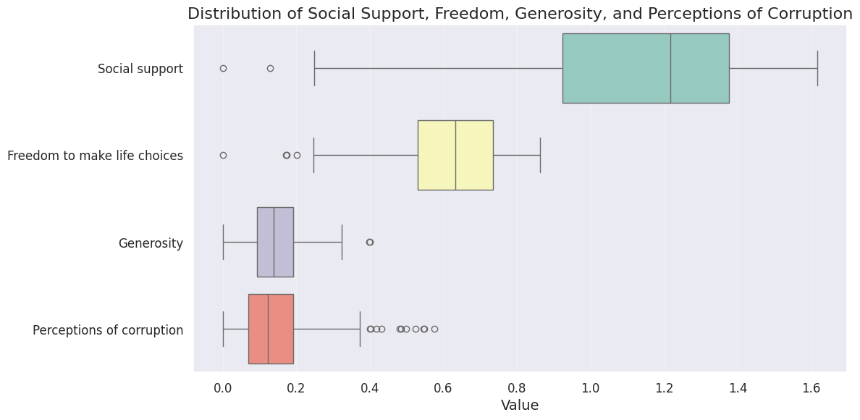

To investigate the potential drivers behind happiness disparities, **Figure 3** visualizes the distributions of four key variables: social support, freedom to make life choices, generosity, and perceptions of corruption. Social support and freedom exhibit relatively high medians and lower variability, highlighting their universal importance across diverse cultural contexts. In contrast, generosity and perceived corruption show wider spreads and more pronounced outliers, suggesting that these factors vary significantly across nations. Countries with high happiness scores tend to combine strong social bonds and institutional trust with greater personal freedom, while those lower on the ladder often contend with systemic corruption and social fragmentation.

**4. Correlation Matrix of Happiness Factors:**

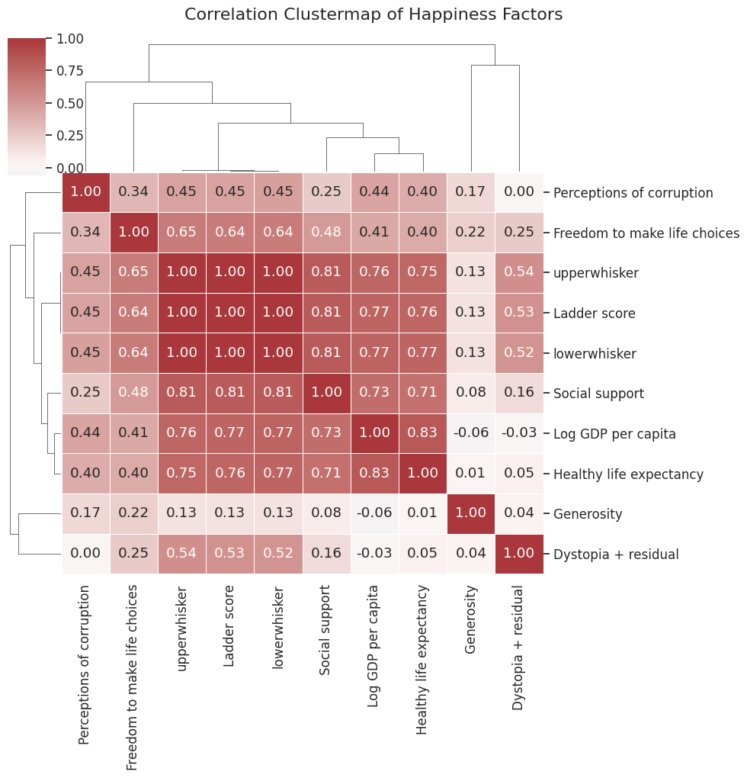

To understand how these variables relate to each other and to happiness itself, **Figure 4** displays a correlation matrix of all major factors in the dataset. Ladder score shows strong positive correlations with Log GDP per capita, social support, and healthy life expectancy, indicating that economic wealth, robust health systems, and supportive communities are crucial for well-being. Notably, generosity and perceptions of corruption show weaker, and in some cases, negative correlations with happiness, highlighting the nuanced and context-dependent nature of these influences. This matrix reinforces that while happiness is multidimensional, certain foundational variables consistently drive higher levels of national life satisfaction.

**Conclusions:**

In summary, the 2024 World Happiness data reveals that well-being is deeply influenced by both economic prosperity and social cohesion. Countries with high happiness scores often benefit from a strong social safety net, personal freedom, and low levels of corruption—factors that transcend GDP alone. While no single variable guarantees happiness, the interplay between economic and societal conditions is clearly vital.

These insights underscore the importance of designing policies that nurture not only economic development but also trust, community support, and institutional strength. As nations strive for higher well-being, a balanced approach that values both material and emotional quality of life will be essential.

**Assumptions:**

* Missing values were either removed or imputed using the mean of the corresponding columns.
* All numeric variables are assumed to be measured consistently across countries.
* The ladder score is treated as a reliable proxy for national happiness and well-being.

**Table 1: Summary Statistics of Key Variables:**

| **Variable** | **Mean** | **Std** | **Min** | **Max** |
| --- | --- | --- | --- | --- |
| Ladder score | 5.53 | 1.17 | 1.72 | 7.74 |
| Log GDP per capita | 1.38 | 0.42 | 0.00 | 2.14 |
| Social support | 1.13 | 0.33 | 0.00 | 1.62 |
| Healthy life expectancy | 0.52 | 0.16 | 0.00 | 0.86 |
| Freedom to make life choices | 0.62 | 0.16 | 0.00 | 0.86 |
| Generosity | 0.15 | 0.07 | 0.00 | 0.40 |
| Perceptions of corruption | 0.15 | 0.12 | 0.00 | 0.57 |

**References**

World Happiness Report 2024 Dataset - [Kaggle](https://www.kaggle.com/datasets/jainaru/world-happiness-report-2024-yearly-updated)